

WEBSITE & DESIGN DEVELOPMENT

Website Design Document



# Website Goal



Where we identify the purpose of our website usually in close collaboration with the client or other stakeholders.

Where we need to consider the following Questions as an initial stage of the design and development process:

1. Who is the website for?
2. What do customers/ users expect to find or do there?
3. Is this website’s primary aim to inform, to sell (ecommerce, anyone?), or to provide a service?

This is the most important part of any web design process. If these questions aren’t all clearly answered in the brief, the whole project can set off in the wrong direction.

It may be useful to write out one or more clearly identified goals, or a one-paragraph summary of the expected aims. This will help to put the design on the right path. Make sure you

understand the website’s target audience and develop a website that achieve the identified goal.

# Scope

Where we give a description of the scenarios and areas that the website will cover. what the finished website will be used for?

Requirements

Outline the functional requirements that the website will allow the users/ customers to do and details on how these requirements will be fulfilled.

Requirement 1

Provide an explanation on this requirement and how it can be done through your website pages

Requirement 2

Provide an explanation on this requirement and how it can be done through your website pages

Sitemap



The sitemap provides the foundation for any well-designed website. It helps give web designers a clear idea of the website’s information architecture and explains the relationships between the various pages and content elements.

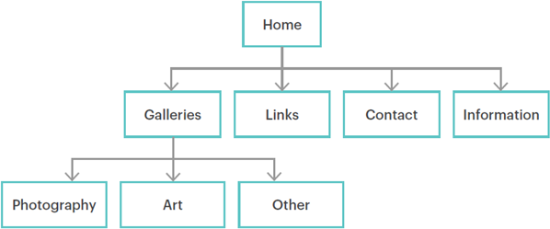

*Note*

* Building a website without a sitemap is like building a house without a blueprint.
* Sitemap captures web pages’ hierarchy in a website.

Wireframes

A wireframe is a layout of a web page that demonstrates what interface elements will exist on web pages.

Wireframes provide a framework for storing the site’s visual design and content elements and elements description.

Wireframes allow stakeholders to see how individual pages within a website will flow and function. And since nothing in a wireframe has been set down in code, stakeholders have the freedom to request drastic changes before you even start designing.

*Notes*

* Although a wireframe doesn’t contain any final design elements, it does act as a guide for how the site will ultimately look. It can also act as inspiration for the formatting of various elements.
* Tools for sitemapping and wireframing
* Pen/pencil and paper
* JustInMind for wireframing mainly.
* Xmind for sitemap mainly.
* Balsamiq
* Moqups
* Sketch
* Axure
* Wireframes can be designed to show how web pages elements will be aligned on different screen sizes. i.e., how a webpage elements’ will be aligned on mobile and on a pc or tablet.

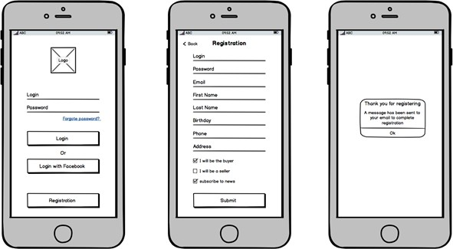

* A table should be added to describe the elements of each wireframe like the titles, buttons, images, paragraphs, logo, icons.

Wireframes for mobile devices:

*Figure 1: Wireframe for login and registration page*

Wireframes for PC screen

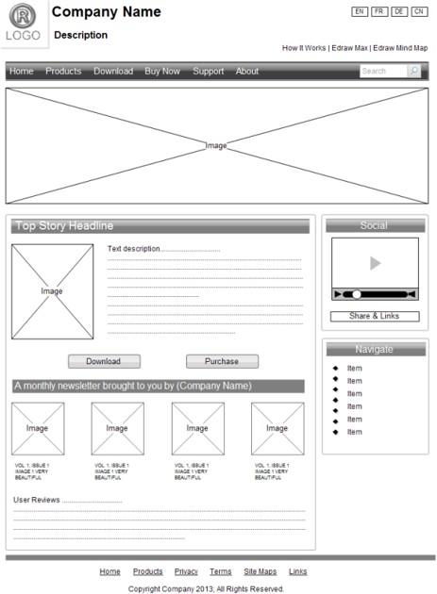

*Figure 2: Wireframe for the website landing page*